Web-activity

NAME:-MEGHAVARSHINI

ROLLNO:-26001600

BRANCH:-AIML-1

CASE:-8
Design a food ordering interface with restaurant details, menu categories, food images, prices, special offers, customer reviews, and order buttons. Use card layouts, attractive backgrounds, and mobile-friendly navigation.

CODE:-

<!DOCTYPE html>
<html>
<head>
<title>Food Ordering Website</title>
</head>
<body bgcolor="lightyellow">

<h1 align="center">Foodie Restaurant</h1>
<p align="center">Delicious Food at Your Doorstep!</p>

<hr>

<h2>Home</h2>
<p>Welcome to our online food ordering website.</p>

<h2>Menu</h2>
<ul>
<li>Pizza - ₹200</li>
<li>Burger - ₹100</li>
<li>Biryani - ₹180</li>
<li>Fried Rice - ₹120</li>
</ul>

<h2>Prices</h2>
<table border="1" cellpadding="10">
<tr>
<th>Food Item</th>
<th>Price</th>
</tr>
<tr>
<td>Pizza</td>
<td>₹200</td>
</tr>
<tr>
<td>Burger</td>
<td>₹100</td>
</tr>
<tr>
<td>Biryani</td>
<td>₹180</td>
</tr>
</table>

<h2>Order Now</h2>
<form>
Name: <input type="text" required><br><br>
Phone: <input type="tel" required><br><br>

Select Food:
<select>
<option>Pizza</option>
<option>Burger</option>
<option>Biryani</option>
<option>Fried Rice</option>
</select><br><br>

Address: <textarea></textarea><br><br>
<input type="submit" value="Place Order">
</form>

<h2>Contact Us</h2>
<p>Email: foodie@example.com</p>
<p>Phone: 9876543210</p>

<hr>
<p align="center">Copyright 2026 Foodie Restaurant</p>

</body>
</html>

OUTPUT:-
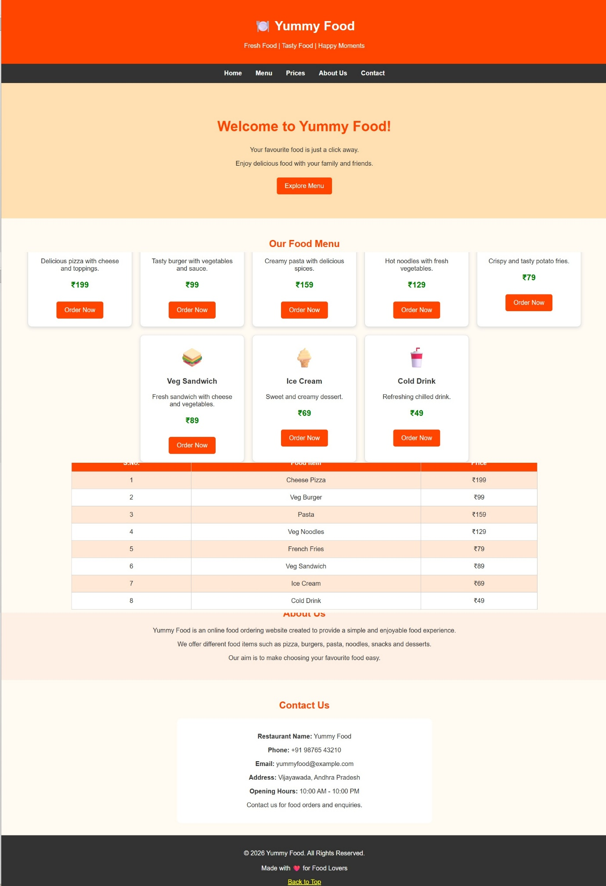

CASE:-12
Design a website displaying doctor profiles, specializations, consultation timings, available appointment slots, and patient registration fields. Focus on clear form labels and easy navigation.

CODE:-

<!DOCTYPE html>
<html>
<head>
<title>Doctor Appointment</title>
</head>
<body>

<center>
<h1>HealthCare Hospital</h1>
<p>Your Health, Our Priority</p>
<hr>
<h2>Doctor Appointment Booking</h2>
<p>Book your appointment with our expert doctors.</p>
</center>

<h2>Our Doctors</h2>
<ul>
<li>Dr. Ravi Kumar - Cardiologist</li>
<li>Dr. Priya Sharma - Dermatologist</li>
<li>Dr. Arjun Reddy - Pediatrician</li>
</ul>

<hr>

<h2>Appointment Form</h2>

<form>
Patient Name:
<input type="text" placeholder="Enter your name" required>
<br><br>

Age:
<input type="number" placeholder="Enter your age">
<br><br>

Gender:
<input type="radio" name="gender"> Male
<input type="radio" name="gender"> Female
<br><br>

Phone Number:
<input type="tel" placeholder="Enter phone number" required>
<br><br>

Email Address:
<input type="email" placeholder="Enter your email">
<br><br>

Select Doctor:
<select>
<option>Dr. Ravi Kumar</option>
<option>Dr. Priya Sharma</option>
<option>Dr. Arjun Reddy</option>
</select>
<br><br>

Appointment Date:
<input type="date">
<br><br>

Appointment Time:
<input type="time">
<br><br>

Describe Your Problem:
<br>
<textarea rows="4" cols="40"
placeholder="Enter your health problem"></textarea>
<br><br>

<input type="submit" value="Book Appointment">
<input type="reset" value="Clear">
</form>

<hr>

<h2>Our Services</h2>
<ul>
<li>General Checkup</li>
<li>Heart Care</li>
<li>Blood Tests</li>
<li>Medical Consultation</li>
</ul>

<h2>Contact Us</h2>
<p>Hospital Name: HealthCare Hospital</p>
<p>Phone: 9876543210</p>
<p>Email: healthcare@example.com</p>
<p>Address: Vijayawada, Andhra Pradesh</p>

<center>
<hr>
<p>Copyright 2026 HealthCare Hospital</p>
<p>Your Health Is Our Priority</p>
</center>

</body>
</html>

OUTPUT:-
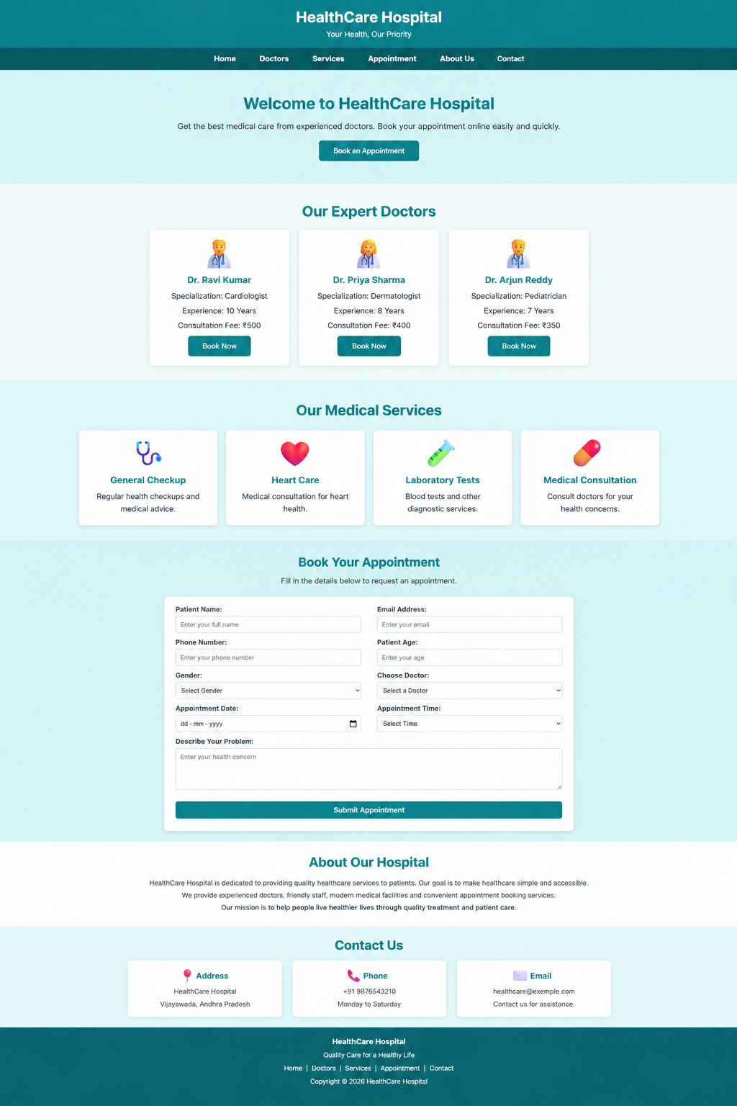

CASE:-26
Build a college festival website displaying technical events, cultural competitions, workshops, schedules, event coordinators, rules, and registration forms. Use category-based cards and responsive event banners.

CODE:-

<!DOCTYPE html>
<html>
<head>
<title>College Fest 2026</title>
</head>
<body bgcolor="lavender">

<h1 align="center">College Fest 2026</h1>
<p align="center">Celebrate Talent, Creativity and Friendship</p>

<hr>

<h2>Home</h2>
<p>Welcome to our college festival!</p>
<p>Date: 20 and 21 November 2026</p>
<p>Venue: College Auditorium</p>

<h2>About Our Fest</h2>
<p>Our college fest includes cultural and technical activities.</p>

<h2>Events</h2>
<ul>
<li>Dance Competition</li>
<li>Singing Competition</li>
<li>Coding Competition</li>
<li>Drawing Competition</li>
<li>Quiz Competition</li>
<li>Gaming Competition</li>
</ul>

<h2>Fest Schedule</h2>
<table border="1" cellpadding="10">
<tr>
<th>Date</th>
<th>Time</th>
<th>Event</th>
</tr>
<tr>
<td>20 Nov</td>
<td>10:00 AM</td>
<td>Dance Competition</td>
</tr>
<tr>
<td>20 Nov</td>
<td>12:00 PM</td>
<td>Coding Competition</td>
</tr>
<tr>
<td>21 Nov</td>
<td>10:00 AM</td>
<td>Singing Competition</td>
</tr>
</table>

<h2>Student Registration</h2>
<form>
Student Name: <input type="text" required><br><br>
Roll Number: <input type="text" required><br><br>
Email: <input type="email" required><br><br>

Department:
<select>
<option>AIML</option>
<option>CSE</option>
<option>ECE</option>
<option>EEE</option>
</select><br><br>

Choose Event:
<select>
<option>Dance</option>
<option>Singing</option>
<option>Coding</option>
<option>Drawing</option>
<option>Quiz</option>
</select><br><br>

<input type="submit" value="Submit Registration">
</form>

<h2>Gallery</h2>
<p>Cultural Programs | Music and Dance | Technical Events</p>

<h2>Contact Us</h2>
<p>College: ABC Engineering College</p>
<p>Email: collegefest@example.com</p>
<p>Phone: 9876543210</p>

<hr>
<p align="center">Copyright 2026 College Fest</p>

</body>
</html>

OUTPUT:-
